***[Insert company name and/or logo]***

**MINNESOTA STATE ROOF CONSTRUCTION OBSERVATION REPORT**

**Construction Progress Report #______ Date:** ***[Insert Date]***

|  |  |
| --- | --- |
| Project #: | 123456 |
| Project Name/Bldg.: | 2016 Reroofng/Main |
| College/University: | Minnesota State College or University |
| Location: | City, MN |
| Reported To: | College/University, Attn: (Campus Project Manager)  Minnesota State system office-Attn: (Program Manager); |
| Architect: | ABC Roof Consultant |
| Contractors: | General=ABC Contracting  Roofing=ABC Roofing Company  Sheet Metal=ABC Sheet Metal Company |
| Observer: | Tom Jones |

|  |  |  |  |  |
| --- | --- | --- | --- | --- |
| Crew Size | | Approximate Squares | Start Time | End Time |
| General: | 5 | N/A | 9:00 am | 2:00 pm |
| Roofing: | 7 | 3 | 7:30 am | 3:30 pm |
| Sheet Metal: | 2 | 3 | 12:00 pm | 5:15 pm |
|  |  |  |  |  |
|  |  |  |  |  |
|  |  |  |  |  |

|  |  |  |
| --- | --- | --- |
| *Observer:* | 7:30 am | 5:15 pm |

**Weather:** Mostly Cloudy, 65º, moderate wind

|  |
| --- |
| **PROJECT STATUS** |
| Work in ProgressSection A |
| Project Start Date: June 4, 2016 |
| Roof Working Day: 20 |
| Allowed Roof Working Days: 45 |
| Percent Complete: 20% |
| Substantial Completion: August 17, 2016 |

**Field Observations:**

Started scupper work today

Sheet metal work started on new curbs.

**MINNESOTA STATE ROOF CONSTRUCTION OBSERVATION REPORT**

***[Insert Date]***

**Issues:**

**Action Taken on Issues:**

**[insert any issues and solutions]**

**CONSTRUCTION PHOTOS**



**MINNESOTA STATE ROOF CONSTRUCTION OBSERVATION REPORT**

***[Insert Date]***

**ROOFING PLAN – Section A**

***[Insert site plan and provide shading to indicate work in progress/completed using keying chart.]***

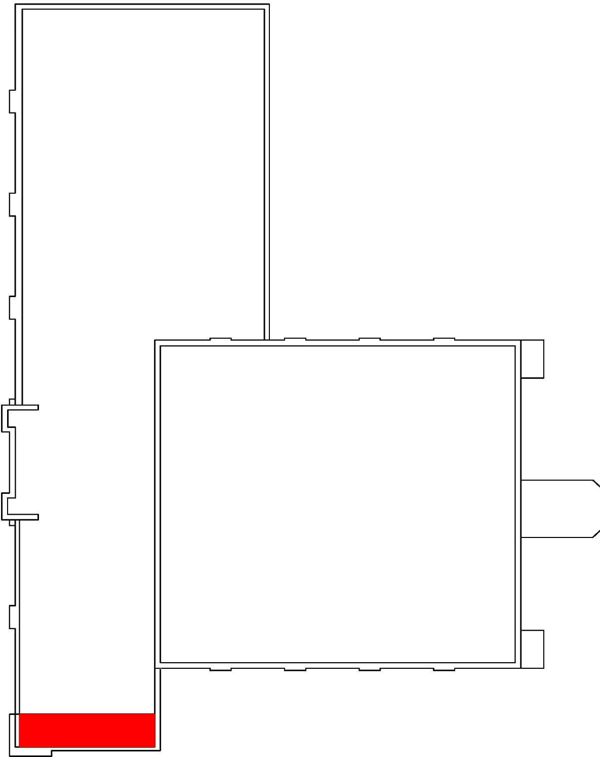



**CURRENT WORK AREA**

**MINNESOTA STATE ROOF CONSTRUCTION OBSERVATION REPORT**

***[Insert Date]***

**TESTING INFORMATTION**

**Moisture Tests:**

**Location:**

**Membrane Sample Evaluation**

|  |  |  |  |  |  |
| --- | --- | --- | --- | --- | --- |
| **# Location** | **Felts & Moppings** | **Average Mopping** | **Overlapping** | **Average Void/Interply** | **Felt-on Felt Sq. In.** |
| 1. |  |  |  |  |  |
| Project Spec: | 135-169 | 27 ± 15% | Satisfactory | 3% Ave. -5% Max. | None |
| In Spec: | □ | □ | □ | □ | □ |

**Bitumen Temperatures**

|  |  |  |
| --- | --- | --- |
| ***Type:*** II | ***Source:*** Kettle | ***Temp: 470***F |
|  |  |  |
|  |  |  |

**Asphalt Softening Test**

|  |  |  |
| --- | --- | --- |
| ***Sample No.*** | ***Softening Point*** | ***ASTM Specification D312*** |
| 1 | 160F | II (158-176) F |
|  |  |  |

**Gravel Samples: N/A**

[insert conformance status of sample]

**MATERIALS ON SITE:**

|  |  |  |
| --- | --- | --- |
| **Material Type** | **Material Description** | **Meets Specification** |
| Bitumen/Adhesives |  | □ |
| Insulation | Tapered Iso | □ |
|  |  | □ |

**Signed:**